# **K-Nearest Neighbours**

K-Nearest Neighbours is one of the most basic yet essential classification algorithms in Machine Learning. It belongs to the supervised learning domain and finds intense application in pattern recognition, data mining and intrusion detection.

It is widely disposable in real-life scenarios since it is non-parametric, meaning, it does not make any underlying assumptions about the distribution of data (as opposed to other algorithms such as GMM, which assume a Gaussian distribution of the given data).

We are given some prior data (also called training data), which classifies coordinates into groups identified by an attribute.

As an example, consider the following table of data points containing two features: 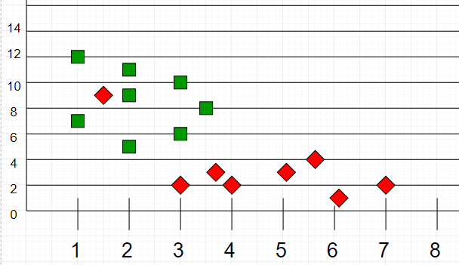

Now, given another set of data points (also called testing data), allocate these points to a group by analyzing the training set. Note that the unclassified points are marked as ‘White’.

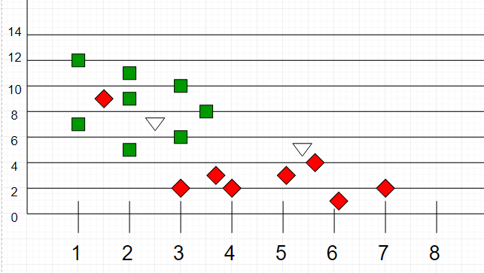

**Intuition**

If we plot these points on a graph, we may be able to locate some clusters or groups. Now, given an unclassified point, we can assign it to a group by observing what group its nearest neighbours belong to. This means a point close to a cluster of points classified as ‘Red’ has a higher probability of getting classified as ‘Red’.

Intuitively, we can see that the first point (2.5, 7) should be classified as ‘Green’ and the second point (5.5, 4.5) should be classified as ‘Red’.

**Algorithm**

Let m be the number of training data samples. Let p be an unknown point.

1. Store the training samples in an array of data points arr[]. This means each element of this array represents a tuple (x, y).

for i=0 to m:

Calculate Euclidean distance d(arr[i], p).

1. Make the set S of K smallest distances obtained. Each of these distances corresponds to an already classified data point.
2. Return the majority label among S.

---------X------------X

KNN is the simplest Classification technique. Although it is susceptible to overfitting and responds very poorly if there are any outliers present in the data.

---------------------